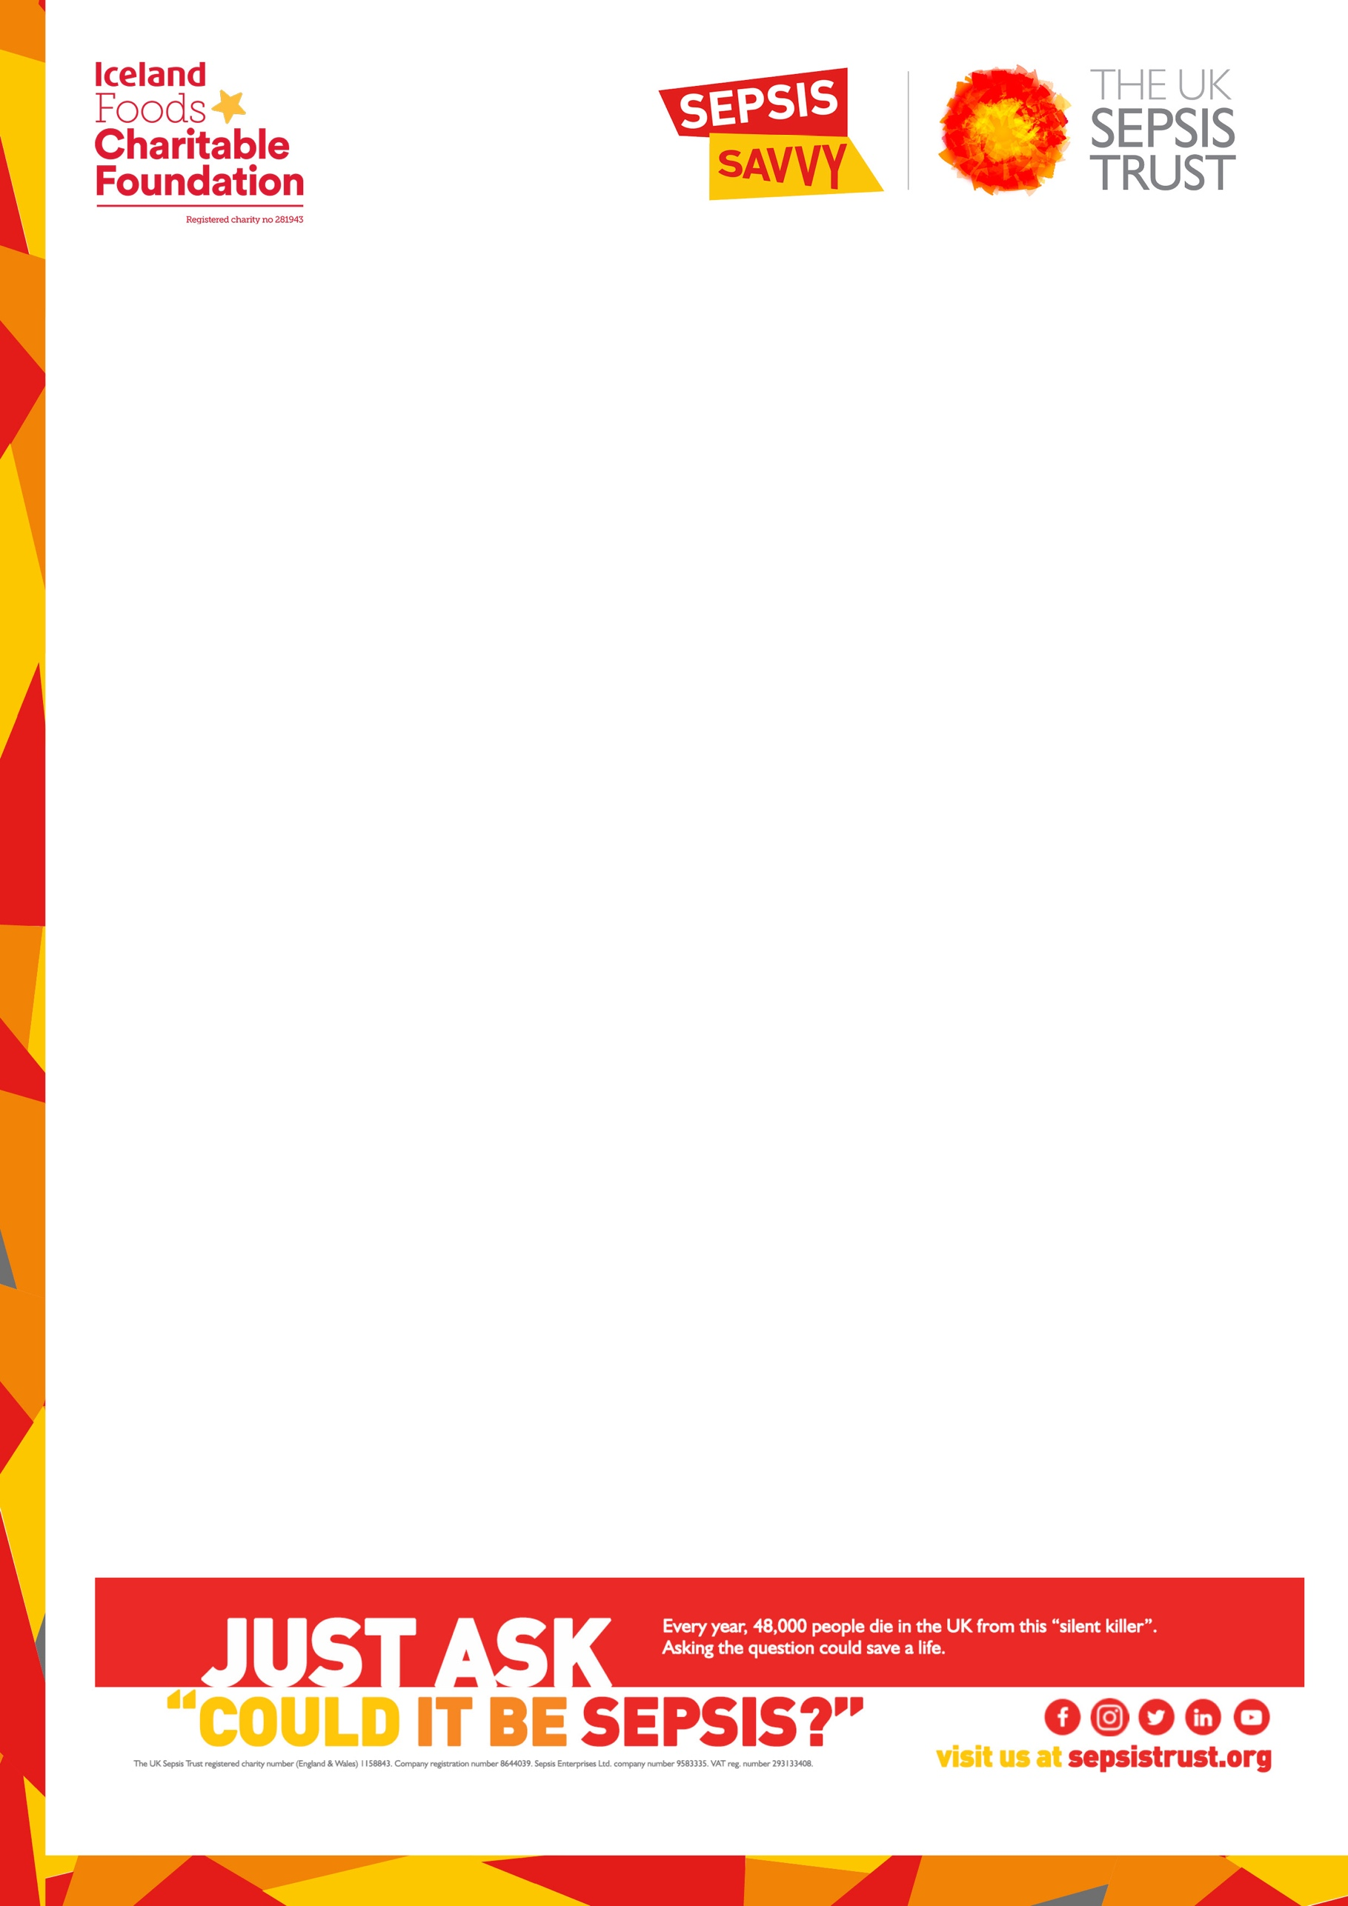
LETTER FOR PARENTS TO SEND INTO SCHOOL
School’s address

Date

Dear <insert head teacher/school name>,

I’ve recently heard from The UK Sepsis Trust (UKST) about their Sepsis Savvy awareness-raising campaign.

As part of this initiative, developed in partnership with Iceland Foods Charitable Foundation, the UKST aims to educate some of the 11.7m school-aged students throughout the United Kingdom about sepsis and the signs to look for.

Sepsis is an emergency medical condition that affects 245,000 adults and children, accounting
for at least 48,000 deaths every year in the UK. That’s 130 deaths every day – 5 every hour! However, the good news is that sepsis is often treatable if it’s caught quickly.

As part of the Sepsis Savvy Resources for Schools – which feature TV paediatrician Dr Ranj Singh and actor Warwick Davis – UKST have developed several FREE resources for schools, including lesson plans and accompanying PowerPoint slides for each Key Stage. The lessons feature embedded videos, teacher notes for all slides, case studies of young people who have suffered from sepsis (KS4/5 lessons only), posters to download and print off to display in school and information cards for staff and children to take home to share with their families.

Awareness really does save lives. That’s why the UK Sepsis Trust have launched these Sepsis Savvy Resources for Schools and why I’m writing to ask if you would consider registering and downloading these resources – it doesn’t cost a penny – and deliver the lesson plans.

For more information and to register as a Sepsis Savvy School, visit https://sepsistrust.org/support-us/campaigns/sepsis-savvy-schools/ email schools@sepsistrust.org or call us on
0800 389 6255.

Thank you
<Insert name>

